An Overview of Radiation Safety: Radiation Protection
Author: Kelli Welch Haynes, Ed.D, RT (R), FASRT, FAEIRS

Outline
- Introduction
- Radiation Protection
  - Minimizing Patient Exposure
    - Exposure factors
    - Beam restriction
    - Patient considerations
    - Filtration
    - Radiographic dose documentation
    - Image receptors
    - Grids
    - Fluoroscopy
    - Dose area product (DAP) meter
  - Personnel Protection (ALARA)
    - Sources of radiation exposure
    - Basic methods of protection
    - Protective devices
    - Special considerations
    - Radiation exposure and monitoring
    - Handling and disposal of radioactive material
  - Conclusions

Learning Objectives
1. Discuss ways to minimize patient exposure to radiation during x-ray procedures.
2. Differentiate between personnel and patient exposure.
3. Examine principles and recommendations for personnel protection to radiation exposure.
4. Review strategies and resulations for monitoring radiation exposure

Highlights
- The goal of radiation protection is to protect patients and radiologic technologist from the short-term and long-term effects of radiation.
- Radiology departments must follow the guidance of NCRP reports #102 and #116.
- Radiologic technologists must wear a dosimeter to monitor their radiation exposure.

Introduction
Today, more than ever, patients demand high-quality care and accountability from their healthcare providers. So medical professionals must assess their knowledge and skills routinely. By doing so, they become better prepared to meet changing standards. This is why many credentialing organizations, including the agency that certifies radiologic technologists (RTs), have created long-term requirements, sometimes called time-limited certification, to maintain credentials. The American Registry of Radiologic Technologists (ARRT) started this process for graduates that completed a radiologic science program after 2010. So, the process is called Continuing Qualification Requirements (CQR). CQR helps radiologic technologists identify skills and gaps in their knowledge and skills that could cause them to fall behind today's entry-level qualifications. CQR enables you to refresh your knowledge, understanding, and ability. CQR applied to all registered radiologist assistants (RRAs) and RTs who earned their credentials on or after January 1, 2010. RTs have three years to complete the CQR process. ARRT will notify you through your online account when your compliance window opens. First, you will complete a professional profile and then take the structured self-assessment (SSA), which utilizes the same content specifications as the radiography examination. Lastly, you will be prescribed continuing education (CE) to complete if the SSA reveals gaps. The prescribed CE activities can also count toward your biennial CE requirement.

The SSA Content Specifications for Radiography are provided to assist radiologic technologists during their CQR compliance period. Targeted CE is assigned only if a standard is not met in a category on the SSA. The SSA is composed of questions designed to evaluate an individual's knowledge of topics related to current practice. Table 1 presents the major categories and subcategories covered on the SSA. The number of questions in each category and the number of questions in each subcategory are in parentheses. The potential number of targeted CE credits that would be prescribed if the standard is unmet is listed at the bottom.

Table 1: Radiography Content Specifications
Content Category | Number of Questions | Potential CE Credits
Patient Care  Patient Interactions and  Management (10) | 10 | 6
Safety  Radiation Physics and  Radiobiology (10)  Radiation Protection (10) | 20 | 4  5
Image Production  Image Acquisition and  Evaluation (10)  Equipment Operation and  Quality Assurance (10) | 20 | 4  5
Procedures  Head, Spine, and Pelvis  Procedures (10)  Thorax and Abdomen  Procedures (10)  Extremity Procedures (10) | 30 | 3  4  5
 | Total 80 | Maximum CE 36

This article follows the Radiation Protection section of the Safety outline of the content specifications for Radiography as published by the ARRT.

Radiation Protection
Radiation is energy that comes from a source and travels through space at the speed of light. Ionizing radiation consists of particles, x-rays, or gamma rays, with sufficient energy to cause ionization in the medium through which it passes. Because of this process, the ionization event may cause injury in normal biologic tissue. Therefore, radiologic technologists (RT) must minimize patient exposure to radiation. Radiation protection aims to protect persons from both short-term and long-term effects of radiation. Radiologic technologists are responsible for ensuring radiation safety during all medical radiation procedures. Lastly, radiation protection protects patients, personnel, and the general public from unnecessary exposure to ionizing radiation.

Minimizing Patient Exposure
Exposure of patients to medical x-rays is commanding increasing attention in our society for two reasons.³ First, the frequency of x-ray examinations is rising among all age groups. This increase indicates that physicians rely increasingly on x-ray diagnosis to assist them in patient care, even considering the newer imaging modalities. X-ray diagnosis is considered much more accurate now than in the past. More rigorous training programs are required of radiologists and radiologic technologists, and improvements in diagnostic X-ray imaging systems allow for more complex but more substantive X-ray examinations, so efficacy and diagnostic accuracy are much improved. Second, concern among public health officials and radiation scientists is increasing regarding the risk associated with medical x-ray exposure. Acute effects on superficial tissues following interventional radiology procedures are frequently reported. The possible late effects of exposure are of concern, so attention must be given to good radiation control practices. When a diagnosis can be obtained with a low radiation dose or an alternate modality such as magnetic resonance imaging (MRI) or ultrasound, it should be used because of reduced risk, keeping with the as low as reasonably achievable (ALARA) principle.

Exposure factors
Selection of appropriate technical factors for each x-ray exam is essential to ensure a diagnostic image with minimal patient dose; therefore, technique selection must ensure sufficient penetration of the area of clinical interest, provide adequate brightness to display anatomic structures, and provide a good amount of subject contrast between adjacent tissues.

kVp
Kilovoltage (kV) measures the electrical force or pressure behind a current of electricity, which causes it to flow.4 Kilovolt peak (kVp) controls the quality, or penetrating power, of the x-ray beam. The optimal kilovolt peak (kVp) and the lowest milliampere per second (mAs) should be used to decrease patient exposure. In general, using a high kVp technique results in reduced patient dose. Increasing the kVp is always associated with reducing mAs to obtain an acceptable radiation exposure of the image receptor. This, in turn, results in reduced patient radiation dose. This reduction occurs because the patient radiation dose is linearly related to the mAs but is related to approximately the square of the kVp. An area of radiography for which the high kVp technique is widely accepted is chest examinations. The selection of scientifically correct technical exposure factors for each x-ray examination is essential to ensure a useful diagnostic image with minimal patient dose. A high-quality image has sufficient brightness to display anatomic structures, an appropriate level of subject contrast to differentiate among structures, the maximum amount of spatial resolution, which is the recorded detail in the radiographic image, and a minimal amount of distortion. The appropriate technical factors are those listed in Table 1.

Table 1.0 Technical Exposure Factors for Consideration
Technical Exposure Factor Considerations
Mass per unit volume of tissue of the area of clinical interest
Effective atomic numbers and electron densities of the tissues involved
Type of image receptor
Source-to-image receptor distance (SID)
Type and quantity of filtration employed
Type of x-ray generator used
Balance of radiographic brightness required

mAs
Milliamperage (mA) measures the quantity of electrical current flowing through a circuit.4 mA is a rate representing the number of electrons passing down a wire per second, which is mAs. Milliampere per second (mAs) controls the quantity of photons in the x-ray beam. Since mA represents the quantity of electrons, it is directly proportional to patient dose. When the kVp is increased, an accompanying reduction in mAs should be used to provide adequate contrast resolution, constant spatial resolution, and a reduced patient radiation dose. The problem with a very low technique for digital imaging is a low signal-to-noise ratio (SNR). This particular type of noise gives the image a salt and pepper appearance, termed quantum mottle or quantum noise. Noise can compromise the interpretation of soft tissue anatomy (Figure 1A and 1B).
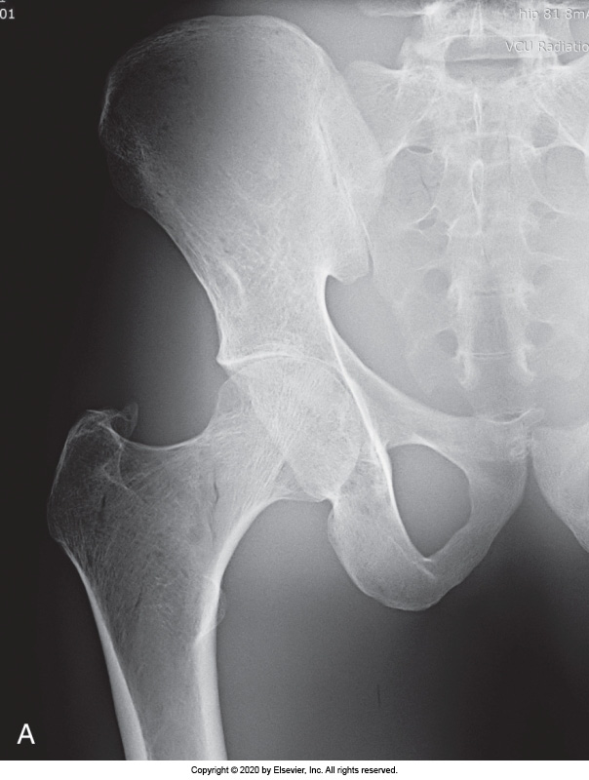
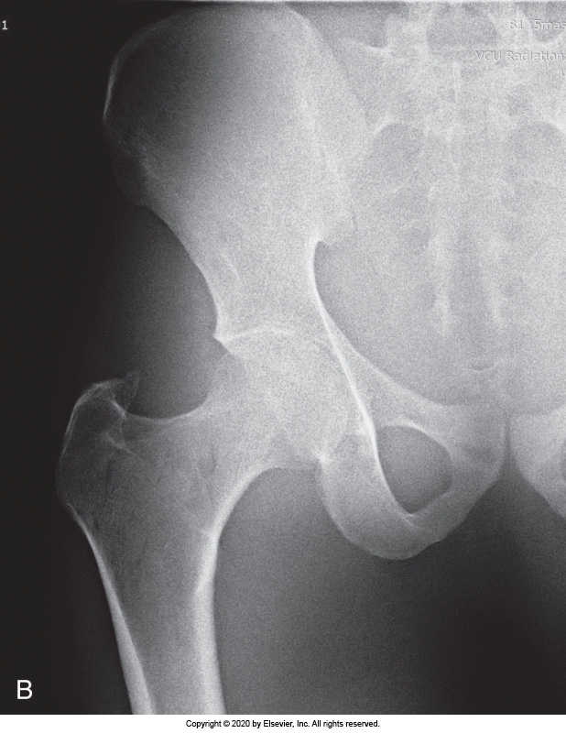

Figure 1A: Quantum Noise. (A) Quality image created using sufficient mAs. (B) Image created using insufficient mAs and results in increased quantum noise visible within the image.²
automatic exposure control (AEC)
Automatic exposure control (AEC) is also something to consider with technical factors.² The AEC requires a thorough understanding on the part of the radiologic technologist. The AEC is a device that measures the quantity of radiation that reaches the image receptor. The AEC automatically terminates the exposure when the image receptor has received the required radiation intensity. The type of AEC that most manufacturers use incorporates a flat parallel plate ionization chamber positioned between the patient and the image receptor. This chamber is made radiolucent to not interfere with the radiographic image. Ionization within the chamber creates a charge when the appropriate amount has been reached; the exposure is terminated. When the RT selects the type of examination, then AEC sets the suitable mA and kVp. At the same time, the exposure time is set to the backup time. When the electric charge from the ionization chamber reaches a preset level, a signal is returned to the operating console, where the exposure is terminated. When images are taken in the AEC mode, the electronic timer should be set to 1 1/2 times the expected exposure time as a backup timer if the AEC fails to terminate the exposure. This precaution should be followed to protect the patient and the x-ray tube (Figure 2)
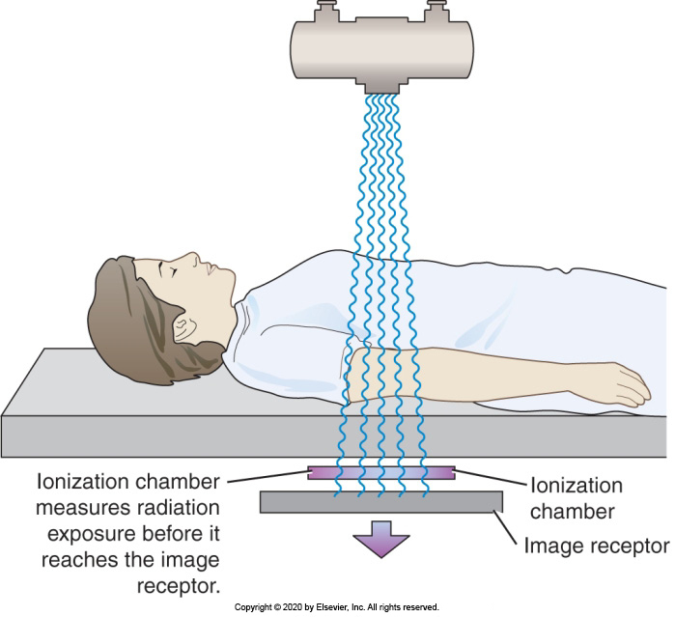
Figure 2: The ionization chamber automatic exposure control system has the detectors located directly in from of the image receptor. This is an entrance-type device because the x-ray exposure is measured before entering the image receptor.

If lead shielding is used during the exam, ensure the x-ray beam is collimated correctly. No portion of the shield should be within the field of view. The AEC is an x-ray termination device designed to produce an acceptable diagnostic image while limiting the total amount of radiation exposure to the patient. The standard type of AEC system utilizes ionization chambers. Most systems have a set of three radiation measuring detectors arranged in some particular manner to monitor the intensity distribution of radiation over the field of view (Figure 3).

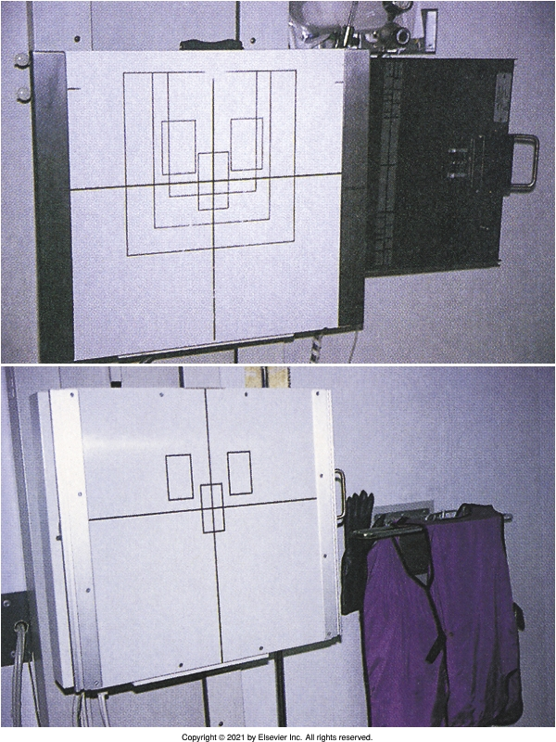
Figure 3: Vertical chest bucky shows the position of automatic exposure control sensors represented as three rectangles.³

Beam restriction
Beam restriction manipulates the field of view to a size smaller than the image receptor.⁴

Purpose of primary beam restriction
The purpose of beam restriction is to confine the useful beam before it enters the area of clinical interest, thereby limiting the quantity of body tissue irradiated and reducing the amount of scatter radiation in tissue, preventing unnecessary exposure to tissues not under examination. ⁴

Types (e.g., collimators)
Collimation restricts the useful beam to the part of the body to be imaged and thereby spares adjacent tissue from unnecessary radiation exposure.⁴ Collimators take many different forms. The adjustable light localizing collimators are the most frequently used collimating devices. Collimation also reduces scatter and thus improves image contrast. The collimator is a light localizing variable aperture rectangular system with two sets of adjustable lead shutters mounted within the device at different levels. It also includes a light source to illuminate the x-ray field and permit it to be centered over the area of clinical interest, and then a mirror to deflect the light beam toward the patient to be imaged. The first set of shutters, the upper shutters, or initial collimation, are mounted as close as possible to the two windows to substantially limit the amount of x-rays emitted from parts of the tube other than the focal spot and exiting at various angles from the x-ray tube window. This off-focus radiation can never be eliminated because the shutters cannot be physically placed immediately beneath the actual focal spot of the x-ray tube. However, by situating them as close as possible to the tube window, the off-focus radiation can be reduced significantly, thereby decreasing the patients' exposure and some potential exposure to the radiologic technologist. The second set of collimator shutters, the lower shutters, are mounted below the level of the light source and mirror and function to further confine the radiographic beam to the area of clinical interest. The second set of shutters consists of two pairs of lead plates oriented at right angles to each other. Each set may be adjusted independently so the RT can select the appropriate size for the radiation field.

Patient Considerations
A few items must be considered regarding the patient when attempting to minimize patient exposure. A holistic approach to patient care is essential during a diagnostic X-ray procedure.⁵ This means considering for treatment the whole person rather than just the area of interest.

Positioning
Radiologic technologists follow a set of common steps for each radiographic procedure, and this improves efficiency, ensures patient safety, reduces mistakes, and minimizes patient radiation exposure.⁵ The order of these steps will vary by the anatomy of interest, patient condition, type of equipment available, and department protocol. More complex procedures involving multiple body parts or fluoroscopy may require additional steps, so we must pay close attention and position our patients properly.

Communication
Effective communication is an interaction that produces a satisfying result through a range of information and can be accomplished through verbal messages, body language, and clear and concise instructions.⁵ This type of dialogue alleviates the patients' uneasiness and increases the likelihood of full cooperation and successful procedure completion. The RT should develop easy, understandable communication skills.

Communication between the RT and the patient is considered effective when verbal and gentle body language or nonverbal messages are understood as intended.. Empathetic communication can reduce anxiety and emotional stress and enhance the professional image of the RT. Effective communication also increases the chance for successful completion of the x-ray examination, reducing the potential of repeat exposures resulting from poor communication.

Patient communication also includes the importance of providing proper patient instructions. Each encounter with a patient during a diagnostic x-ray procedure should begin with clear and concise instructions. When healthcare professionals do not thoroughly explain procedures, patients fear the unknown and become anxious, especially during lengthy examinations. To alleviate the problem, the RT must take adequate time to explain the procedure in simple terms that the patient can understand. The patient should also be allowed to ask questions. The RT must listen attentively to these questions, answer them truthfully in an appropriate tone, and follow ethical guidelines. This creates a sense of trust between the patient and the RT and encourages any further discourse.

Pediatric Patients
Children are much more vulnerable to radiation's late effects than adults, requiring special consideration when undergoing diagnostic x-ray studies.⁵ Some of these considerations include that children have a greater life expectancy. They may easily survive long enough to develop late effects from radiation exposure, such as leukemia, or other malignancies, such as lung or thyroid cancer. After a substantial dose of ionizing radiation, the risk of radiation-induced leukemia in children is approximately 2 times that of adults. The data for low doses, such as those generally encountered and conventional diagnostic radiology, is still inconclusive. So with this concern in mind, radiologic technologists must take every precaution to minimize exposure in all pediatric patients. Smaller doses of ionizing radiation are sufficient to obtain useful images in pediatric imaging procedures than those necessary for adult imaging procedures.

Patients who are morbidly obese
Obesity in the United States has increasingly been cited as a significant health issue in recent decades. ⁵ While many industrialized countries have experienced similar increases, obesity rates in the United States are among the highest in the world. Patients who are considered obese are at risk for increased radiation exposure due to increased radiation needed to penetrate tissue, the risk of repeat exams due to difficult positioning and technique, and an incompatibility with the existing equipment. And obese patients suffer from health conditions requiring more radiologic procedures than the average population. When imaging patients who are morbidly obese, it is best practice to use manual techniques instead of the AEC and remember that ALARA is our ethical responsibility to ensure patient exposure is kept to a minimum by keeping exposures as low as reasonably achievable.

Filtration
Filtration of the radiographic beam results in the absorption of most of the lower energy photons from the heterogeneous beam; this increases the mean energy or quality of the x-ray beam and is commonly referred to as hardening the beam.² The remaining photons will have higher mean energy and are less likely to be absorbed via the photoelectric interaction in body tissue. On the other hand, if adequate filtration were not present, very low energy photons would enter the patient and be almost totally absorbed in the body, thus markedly increasing the patients' radiation dose, especially near or at the surface, but contributing nothing to the imaging process. In general radiography, the low energy photons should be removed from the radiographic beam through proper filtration to reduce the absorbed dose to the patient. The filter material includes elements inherent to and added to the x-ray equipment.

Effect on skin and organ exposure
Filtration decreases exposure by absorbing most of the lower energy photons. Therefore, skin and organ exposure are reduced.

Effect on average beam energy
Filtration increases the beam's energy, or quality, decreasing the radiation's overall intensity.

NCRP Recommendations (NCRP #102, minimum filtration in useful beam)
The National Council on Radiation Protection and Measurements (NCRP), in report #102, provides recommendations regarding the design for optimal use of radiographic equipment and includes radiation protection and personnel monitoring.² This report states that 2.5 millimeters of aluminum or aluminum equivalent are required when operating equipment above 70 kVp. This 2.5 includes inherent filtration plus 1.0 of added filtration.

Radiation Dose Documentation
In the early 1990s, the United States Food and Drug Administration (FDA) received reports of significant radiation-induced skin injuries associated with interventional fluoroscopy, prompting the release of three guidance publications on documenting radiation use.³ Several professional societies started working then to reduce the frequency of these events. In 2007, the American College of Radiology (ACR) published its recommendations on patient radiation exposure in medicine. This document focuses mainly on diagnostic imaging procedures such as computed tomography and nuclear medicine, not interventional ones. The ACR's report included the management of radiation and fluoroscopically guided procedures. These fluoroscopically guided invasive procedures may require the use of significant quantities of radiation for their completion, which can put patients at risk for deterministic radiation injuries. In addition, all irradiated patients are at risk for an increased incidence of stochastic injuries. The guidelines for interventional radiologic procedures included patient selection, procedure performance, patient monitoring, and appropriate documentation and follow-up. In diagnostic radiography, the highest doses of radiation are to patients during interventional procedures. Therefore, radiation dose should be monitored throughout the procedure. This responsibility may be delegated to a technologist, nurse, or other personnel depending on the institution’s policy, and needs and following relevant laws and regulations. On radiographic equipment that monitors fluoroscopy time, the operator is notified when the total fluoroscopy time has reached 5 minutes, and then it will sound an audible alarm. So everyone will be alerted, and the total fluoroscopy time must be recorded in the patient chart at the end of the procedure.

Image Receptors
With the acceleration to all-digital imaging, patient radiation dose has decreased by 20%-50% depending on the examination.² A reduction in patient radiation dose is possible because of how the digital image receptor responds to x-rays. Further dose reduction can be achieved by reduced repeat exposures due to technical factors. Exposures should not be repeated in digital radiography (DR) because of brightness or contrast concerns. The image receptor can make adjustments through processing.

Grids
Grids are typically placed between the patient and the remnant x-ray beam.⁴ In practice, a grid should be used anytime we are imaging a body part that is 10 centimeters or thicker. Body parts that are thicker than 10 centimeters will increase the amount of scatter produced, a grid is utilized to absorb some of that scatter before it reaches the image receptor, and in that manner, grids increase image quality.
Modern grids are sufficiently well manufactured so that many radiologists do not find the grid lines of stationary grids objectionable, especially for mobile radiography and horizontal views of an upright patient. However, the virtual grid is changing this. Selecting a grid with the proper ratio depends on understanding three interrelated factors: kVp, degree of scatter radiation reduction, and patient radiation dose. When a high KVP is used, high-ratio grids should also be used. As the grid ratio increases, scatter radiation attenuation also increases. The difference in patient radiation dose moving from a 12:1 grid to a 16:1 grid is significant; however, 16:1 grids are not often used because the higher the grid ratio warrants an increase in technical factors to penetrate the grid. Most x-ray examination facilities find that an 8:1 grid represents a good compromise between the desired levels of scatter radiation reduction and patient radiation dose. The latest innovation for removing scatter radiation and improving image contrast is the digitally reconstructed radiograph, a virtual grid. The virtual grid is now offered in the software packages available in DR, which has virtually eliminated the use for an actual grid when examining our patients.

Fluoroscopy
Fluoroscopy is an imaging technique that uses x-rays to obtain real-time moving images of anatomic structures on a monitor that works with an image signal amplification system.³ Fluoroscopic procedures produce the most significant patient radiation exposure rates in diagnostic radiology. Therefore, the referring physician should carefully evaluate whether the potential benefit to the patient in terms of information gained outweighs any possible adverse somatic or genetic effects of the examination. If a fluoroscopic procedure is necessary, every reasonable effort must be taken to minimize patient exposure.

Pulsed
Pulsed or intermittent fluoroscopy involves manual or automatic periodic activation of the fluoroscope rather than continuous activation. ³ This practice significantly decreases patient dose, especially in lengthy procedures. In pulse mode, the system software automatically turns the radiation beam on and off at an operator-selected repetition rate. The most common rates are 30, 15, or 7 1/2 pulses per second, with each radiation pulse lasting no more than 10 milliseconds. Shorter pulse durations lessen the effects of any patient motion, thereby improving the sharpness of the image, but decrease the signal-to-noise ratio because of the smaller number of X-rays involved.

Exposure factors
During fluoroscopy, the x-ray tube is operated at less than 5 mA.³ Contrast this with the radiographic exam in which the x-ray tube current is hundreds of mA. Despite the lower mA, the patient radiation dose is considerably higher during fluoroscopy than during radiographic examinations because the x-ray beam exposes the patient continuously and for a significantly longer time. The kVp of operation depends entirely on the section of the body being examined.

Grids
As previously stated, grids should be used anytime we are imaging a body part that is 10 centimeters or thicker. The higher the grid ratio, the higher the technical factors needed to penetrate the grid. Grids are standard components in fluoroscopic equipment.

Positioning
The patient should be properly positioned for the examination to reduce the patient's radiation dose.³

Fluoroscopy Time
A cumulative timer must be provided and used with each fluoroscopic unit.³ The timer measures the x-ray beam-on time and sounds an audible alarm when the fluoroscope has been activated for 5 minutes. The timer also serves to alert the radiologist to the amount of time the patient has been receiving x-ray exposure. Total fluoroscopic beam on-time should be documented for every fluoroscopic procedure.

Automatic Brightness Control (ABC) or Automatic Exposure Rate Control (AERC)
Fluoroscopic equipment allows the radiologist to select an image brightness level that is subsequently maintained automatically by varying the kVp, the mA, or sometimes both.³ This feature is automatic brightness control or automatic exposure rate control. These systems produce constant image brightness on the flat panel digital display device, regardless of the thickness or composition of the anatomy. Therefore, these devices may indeed increase the patient’s dose.

Receptor positioning
The image receptor used in fluoroscopy is an image intensifier.³ This electronic device converts the x-ray beam intensity into a visible image that is displayed on a display monitor. During fluoroscopy examinations, the image intensifier is positioned above the patient, and the x-ray tube is under the patient.

Magnification mode
For better visualization of small body parts, such as arteries, the fluoroscope can magnify the image.³ However, the use of magnification requires higher mA, which produces additional radiation exposure. Magnification mode should be used sparingly.

Air KERma Display
Kerma is an acronym for Kinetic Energy Release per unit mass.³ It is defined as the sum of the initial kinetic energies of all the charged particles liberated by uncharged ionizing radiation in a sample of matter divided by the mass of the sample. This unit is also used to measure radiation dose, and many fluoroscopy systems will now display this air kerma on the unit. Hence, the radiologist can determine how much patient dose the patient has received.

Last-image hold
Last image hold is a a dose reduction technique utilized in fluoroscopy.³ For this feature, the image is formed when the x-ray tube was last energized, and the image remains on the monitor so that no further radiation exposure is needed to regenerate it. In a digital system using embedded processing software, this retained image could also be composed of several frames of information that have been added together to reduce the effect of quantum noise that would be particularly apparent in a single frame.

Dose or time documentation
As previously stated, the fluoroscopic dose or the time that the beam-on must be documented.

Minimum Source-to-Skin Distance (21 CFR)
When the distance between the x-ray tube and the patient increases, the mA must be increased to compensate for the increased distance to maintain exposure to the image receptor.³ Therefore, to limit excessive entrance irradiation of the patient, radiologic technologists need to ensure that the source-to-skin distance is not less than 38 centimeters for stationary or fixed fluoroscopes and not less than 30 centimeters for mobile fluoroscopes or C- arms.

Dose Area Product (DAP) Meter
Dose Area Product (DAP) is a quantity that reflects the patient radiation dose and the amount of tissue irradiated.² Therefore, it may be a better indicator of risk than dose. DAP is expressed in units of milligray in the air per centimeter squared. DAP increases with increasing radiation field size, even if the dose remains unchanged. A smaller field size results in lower DAP and less risk because less tissue is exposed. DAP meters are now standard on most x-ray imaging systems and may be used to monitor radiation output from imaging systems. Typically, the DAP detector is positioned just after the X-ray beam collimator before the beam enters the patient. The DAP detector is a transmission ionization chamber larger than the x-ray beam. The ionization detected in the chamber is proportional to the radiation dose and the area of the x-ray beam. The risk for injury to the skin where the x-ray beam enters the patient can be derived by dividing the DAP measurement by the area of the beam at the skin.

Personnel Protection (ALARA)
Because x-rays involve ionizing radiation that can deposit energy in human cells and cause tissue changes, it is crucial to minimize the radiation dose to the patient as well as to the RT.³ This is done by limiting the radiation exposure to the minimum required to create the images that are needed.

Sources of Radiation Exposure
The best way for radiologic technologists and radiologists to conscientiously employ the ALARA principle is to use all appropriate radiation control procedures to minimize exposure levels.³ RTs should faithfully employ procedures such as time, distance, and shielding, adequately collimating the beam and other dose reduction methods and techniques. Methods and techniques that reduce patient exposure can also reduce exposure to the RT, thereby limiting occupational exposure.

Primary X-ray Beam
Primary radiation is radiation that comes directly from the x-ray tube, and the technologist should never be in the line of the primary x-ray beam.³

Secondary Radiation
We have two kinds of secondary radiation; scatter and leakage.³ Scatter radiation results whenever a diagnostic x-ray beam passes through matter, then it emerges from the patient and spreads in all directions. Leakage radiation is generated in the x-ray tube and does not exit from the collimator opening but penetrates through the protective tube housing and, to some degree, through the sides of the collimator. Leakage radiation is always present in some amount. Lastly, the patient is also a source of radiation exposure to the technologist through scatter radiation.

Basic Methods of Protection
The primary methods of radiation protection are time, distance, and shielding.³ Occupational radiation exposure of imaging personnel can be minimized by using these cardinal principles.

Time
The amount of radiation an RT receives at a particular location is directly proportional to the time the individual is in the path of ionizing radiation.³ A reduced exposure time during fluoroscopy will decrease patient and personnel exposure.

Distance
Distance is the most effective means of protection from ionizing radiation because there is a significant decrease in the radiation level due to the dispersion or spread of the radiation beam.³ By increasing distance, the RT will receive significantly less radiation exposure by standing farther away from the source of radiation.

Shielding
When it is not possible to use the principles of time and/or distance to minimize occupational radiation exposure, lead shielding may provide adequate protection from radiation.³

Protective Devices
Accessory protective devices include aprons, gloves, shields, and barriers.³

Types (ex., barriers, aprons)
Radiography and fluoroscopy rooms have protective structural shielding, which is shielding that is built into the structure of the room.³ Structural barriers such as walls and doors in an x-ray room have been designed to shield the imaging department personnel and the general public from radiation. These barriers are necessary to ensure that occupational and non-occupational annual effective dose limits are not exceeded. Lead-impregnated drywall is used in the radiography or fluoroscopy room walls to shield adequately. A primary barrier protects against primary radiation, the beam coming directly from the x-ray tube. In contrast, secondary protective barriers protect against secondary radiation, which has been deflected from the primary beam as scatter or leakage. The control booth is considered a secondary barrier because primary radiation should never be directed toward the control booth. Lead shields are used by RTs when time and or distance cannot be utilized.

Attenuation Properties
Attenuation is the reduction in radiation intensity that results from absorption and scattering.³ Protective devices attenuate radiation differently Based on the material they are made of.

Minimum Lead Equivalent (NCRP #102, 21 CFR)
NCRP report # 102 has established the minimum lead equivalents for protective devices. It is required that lead aprons are a minimum of .25 millimeters (mm) of lead or lead equivalent.³ However, .5 mm is recommended. Gloves should be a minimum of .25 mm. Thyroid shields should be .5 mm, and protective glasses must be a minimum of .35 mm thick.

Special Considerations
Mobile radiographic systems create special radiation protection considerations for the radiologic technologist.

Mobile Units
Some states require RTs to wear lead aprons when performing mobile, radiographic, or fluoroscopic examinations.³ A protective apron should be assigned to each mobile unit to be immediately available for the RT. The most recent mobile units are equipped with a remote-control exposure device. This permits the RT to leave the immediate vicinity and uses the cardinal principle of distance to protect from radiation. Most mobile units, though, are not remotely controlled; for those units, the cord leading to the exposure switch must be at least six feet or two meters long to increase the distance from the patient, the x-ray tube, and the useful beam. The RT should also attempt to stand at a right angle or 90 degrees to the x-ray beam scattering object, which is the patient. This is where the least amount of scatter radiation is received. Figure 1 demonstrates where to stand if the RT must be near the patient.
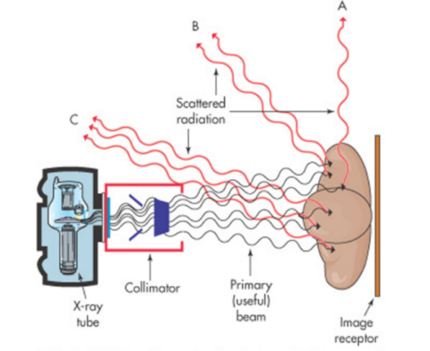
Figure 3: Position A would be the safest place to stand. However, because distance and shielding have much more influence on reducing exposure to the technologist, those factors should be addressed first.³

Fluoroscopy
Protective devices are critically important when mobile fluoroscopy or C-arm systems are used because patterns of exposure direction are less predictable, and the equipment is frequently operated by physicians whose training and experience and radiation safety may not match those of an experienced radiologist or radiologic technologist. ³

Protective Drapes
The NCRP has established these minimum requirements; the protective curtain should be a minimum of .25 mm of lead or lead equivalent.³

Protective Bucky Slot cover
The Bucky slot cover should also be .25 of lead or lead equivalent.³

Cumulative timer
The cumulative timer should sound at 5 minutes.³

Remote-controlled Fluoroscopy
A recent development in equipment is remote-controlled fluoroscopy, another dose-reduction technique.³

Guidelines for Fluoroscopy and Mobile Units (NCRP #102, 21 CFR)
The NCRP has also established these minimum requirements for fluoroscopy and mobile units. ³

Fluoroscopy Exposure Rates (normal and high-level control)
Requirements from NCRP report # 102 include fluoroscopy entrance exposure rates for the general purpose fluoroscopy unit cannot exceed 8.8 cGy/minute, and the high-level control fluoroscopy cannot exceed 20 to 40 Cgy/minute.³

Exposure Switch Guidelines
The exposure switch must be of the dead man type. ³

Radiation Exposure and Monitoring
Some means of monitoring personnel exposure must be employed to ensure that occupational radiation exposure levels are kept well below the annual effective dose limit.³ The RT and other occupationally exposed persons, such as speech-language pathologists, should be aware of the various radiation exposure monitoring devices and their functions.

Dosimeters³
Personnel dosimetry is the monitoring of equivalent dose to any person occupationally exposed regularly to ionizing radiation.³ A personnel dosimeter should be lightweight, easy to carry, and constructed of materials durable enough to tolerate everyday daily use. The dosimeter must be able to detect and record both small and large exposures consistently and reliably.

Types³
Dosimeters are the principal monitoring device, and they will only record the exposure in the area where it is worn.³ There are four different kinds of personnel dosimeters; pocket ionization chambers, optically stimulated luminescent (OSL) dosimeters, thermoluminescent dosimeters (TLD), and the direct ion storage (DIS) dosimeter.

Pocket Ionization Chambers
The pocket ionization chamber is one that physicists typically use because it can be carried in their pocket.³ It is the most sensitive to radiation, but technologists rarely use it because they are costly and inconvenient if they are to be used every day. They contain a small ionization chamber that measures exposure. They are compact and easy to carry. However, they must be charged to 0, and it has to be read every day as there is no record of the reading, so the RT would need to write down the reading every day. Pocket ionization chambers are accurate from zero to 200 millisieverts.

Optically Stimulated Luminescent (OSL) Dosimeter
The OSL dosimeter is made of an aluminum oxide detector.³ When laser light is incident upon the sensing material, it becomes luminescent in proportion to the radiation exposure received. The optically stimulated luminosity occurs when the laser light strikes it, and these are accurate to as low as one millisievert.

Thermoluminescent Dosimeter (TLD)
The TLD contains a crystalline form of lithium fluoride.³ When the lithium fluoride is exposed to radiation, radiation causes the lithium fluoride crystals to change in some of their physical properties, making the TLD very accurate. The TLD is not as sensitive as the OSL. Still, these can be worn for as long as four months. Also, the crystal can be reread if a reading does not seem correct.

Direct Ion Storage (DIS)
The most recently develop dosimeter is the personnel DIS dosimeter.³ This dosimeter uses electronic components developed in the 1990s and was first applied to miniaturized personal dosimetry systems in the early 2000s. The DIS is a small ionization gas-filled dosimeter connected to a solid-state device with electronically erasable programmable read-only memory. When radiation ionizes the gas in the ionization chamber, the cumulative electric charge is stored in the memory. It will remain in the device indefinitely until either added to by additional ionization or until read out by introducing a remote-control signal. The amount of charge stored in the device is directly proportional to the amount of ionization in the chamber. The DIS dosimeter is read out through a physical connecting device, such as a USB Port or over a wireless connection, and the data can be stored electronically at the facility. So the individual wearer may obtain an instant readout while the facility can maintain their records, such as radiation exposure, summary, and exposure history.

Proper Use
Regardless of the type of dosimeter used, it should be worn at the collar to approximate radiation dose to the thyroid, head, and neck. ³ When wearing a lead apron, the dosimeter should be worn outside the apron.

NCRP Recommendations for Personnel Monitoring (NCRP #116)
NCRP report # 116 contains personnel monitoring recommendations, including equivalent dose limits.³ These limits include annual occupational exposure, public exposure, embryo/fetus exposure, and dosimetry records.

Occupational Exposure
Occupational exposure should not exceed 50 millisieverts (mSv) per year.³

Public Exposure
For the public, frequent exposure should not exceed 1 millisievert per year. Infrequent exposure is 5 millisieverts per year.³

Embryo/Fetus Exposure
The embryo/fetus exposure should not exceed .5 millisieverts a month, or the entire gestation should not exceed 5.0 millisieverts.³

Dose Equivalent Limits
Federal government standards follow recommendations of the NCRP reports.³

Evaluation and Maintenance of Personnel Dosimetry Records
And lastly, NCRP reports state that dosimetry records must be kept at the facility where that individual is employed, and a radiation safety officer must be available to review these reports and ensure the staff is educated.³

Handling and Disposal of Radioactive Material
The presence of partially used or unused radioisotopes and any items that they have contaminated necessitates appropriate procedures for their handling and disposal.³ When the radioisotopes are in a liquid form, gloves must be worn, and personnel must wear a dosimeter and follow the cardinal rules of radiation protection. No solid encapsulated radioactive surface should ever be touched by hand. Instead, tongs should be used.

Conclusion
This article follows the second section of the Safety, Radiation Protection outline of the content specifications for Radiography as published by the ARRT.¹

References

1. American Registry of Radiologic Technologists (ARRT). Continuing Qualification Requirements. 2010). Accessed June 17, 2023. https://www.arrt.org/pages/complete-business/manage-credentials/complete-cqr.
2. Bushong, SC. Radiologic Science for Technologists: Physics, Biology and Protection. 12th edition. Elsevier,;2021.
3. Statkiewicz Sherer MA, Visconti PJ, Ritenour ER, Haynes, KW. Radiation Protection in Medical Radiography. 9th edition. Elsevier,; 2022.
4. Carroll, QB. Radiography in the Digital Age. 3rd edition. Thomas Publisher,; 2018.

